

**IN THE SENATE OF SPOOKVOOPER AND THE EMPIRE OF VOOPERIA**

**Environmental Safety Act**

*Written By: Weatherman SillyPossibility*

*With contributions by Senator Snovaltica and Senator Luka*

**Environmental Safety Act**

**SEC. 1. SHORT NAME**

ESA

**SEC. 2. INFORMATION**

(a) (1) *SUMMARY OF THIS ACT*.—

*This Act will establish an official Weather Service of Vooperia with extra responsibilities, so that citizens can be better informed about environmental issues, as well as providing additional ways for citizens to be safe from natural disasters, pandemics and etc.*

1. **VOAA Establishment**
2. The VOAA shall be established with the purpose of providing accurate and up to date meteorological information, and being in
3. The VOAA shall be classified as its own ministry.
4. **VOAA Responsibility and Purpose**
5. The VOAA shall be responsible for providing accurate climatological data for every district capital weekly;
6. The high and low temperature
7. The chance of rain
8. A Weather Map with Pressure Systems, and Cloud Cover
9. Any additional advisories or warning including;
10. Natural disaster warnings
11. Air quality advisories
12. High wind advisories
13. Other unique disasters (Mudslides, avalanches, etc.)
14. Pandemic, epidemic, and endemic advisories, and their control.
15. Any astrological activity/events.
16. The VOAA shall be responsible for providing updates about the following natural disasters, and diseases control;
17. Tropical Storms and Hurricanes
18. Tsunamis
19. Severe Thunderstorms and Blizzards
20. Wildfires
21. Tornadoes
22. Meteors
23. Asteroids
24. Comets
25. Cosmos activity
    1. Or any astrological activity/events
26. VOAA has to notify the Senate and any local government of any imminent danger that’s about to occur regarding VOAA, and its purpose and responsibility.
27. VOAA has to also notify the Senate and any local government of any pandemic, epidemic, and endemic. And VOAA will also be the place for information about diseases, recommendations, and their updates.

1. **VOAA Leadership**
2. The leader of the VOAA shall have the title of “Chairman”
3. Chairman of the VOAA shall be picked out by any Senator and proposed in proposals. And then Senate shall vote on the picked out people.
   1. To appoint a person, they need ⅔ of votes majority.
   2. Anyone can be picked and voted for VOAA Chairman position.
4. The VOAA Chairman must meet the following requirement.
5. Must be active enough to perform the responsibilities (See 3.D)
6. The Chairman of VOAA shall have the following responsibilities;
7. Communication with district Senators about natural disasters.
8. Advisory with district Senators about when to issue watches, warnings, evacuations, and other emergency response measures.
9. Providing weekly weather updates to keep citizens informed.
10. Providing careful documentation of all VOAA funds;
11. Advertisements can be placed on weekly updates as long as they are disclosed as advertisements in.
12. VOAA may also receive public donations
13. The income and expenditure must be carefully documented and available to the public.
14. These funds shall be used to provide weekly salaries to employees.
15. The weekly salary of the Chairman or any employee shall not exceed 1000 credits.
16. The Chairman of VOAA may be impeached by the Senate for the following reasons;
17. Inactivity
18. Using their platform to spread a political message or for undisclosed sponsorships
19. Mismanagement of funds (See 3C.IV)
20. Vetoing legitimate states of emergency (See 4A.I)
21. Failing to meet the responsibilities listed under 3D
22. Other reasons approved by Lower Court
23. **Other Functions of VOAA**
24. Weather Stations
25. Any citizen may send an application to the VOAA chairman to have a weather station.
26. Weather stations can either be an existing district capital (so that the VOAA chairman is no longer responsible for providing climate data for this city)
27. Weather stations can also be set up in places that do not already have reported weather
28. Responsibilities of having a weather station;
29. Must provide weekly reports as laid out in 2A
30. *Out of Character Note: Weather reports must be realistic for both region and surrounding weather*
31. **Senator Emergency Powers**
32. In times of natural disaster, Senators may declare a state of emergency;
33. If the State of Emergency is illegitimate, the VOAA Chairman may veto the declaration.
34. In times when citizens are at threat but the Senator is unresponsive, the VOAA Chairman may declare a state of emergency and will have access to emergency powers. (See 4B)
35. Emergency Powers
36. Senators may provide watches and warnings for various areas.
37. Senators may issue evacuations of certain areas.
38. Senators may have partial control over local municipal systems.
39. Senators may request Emergency Funds from the national government.
40. Senators may send out emergency alerts to all citizens for guidance and information.
41. Senators may deploy local flood trucks or firefighting aircraft.
42. **City Safety Accommodations**
43. Any city with population excess of 100,000 people must have the following safety accommodations;
44. Firefighting aircraft
45. Flood trucks
46. Emergency shelters

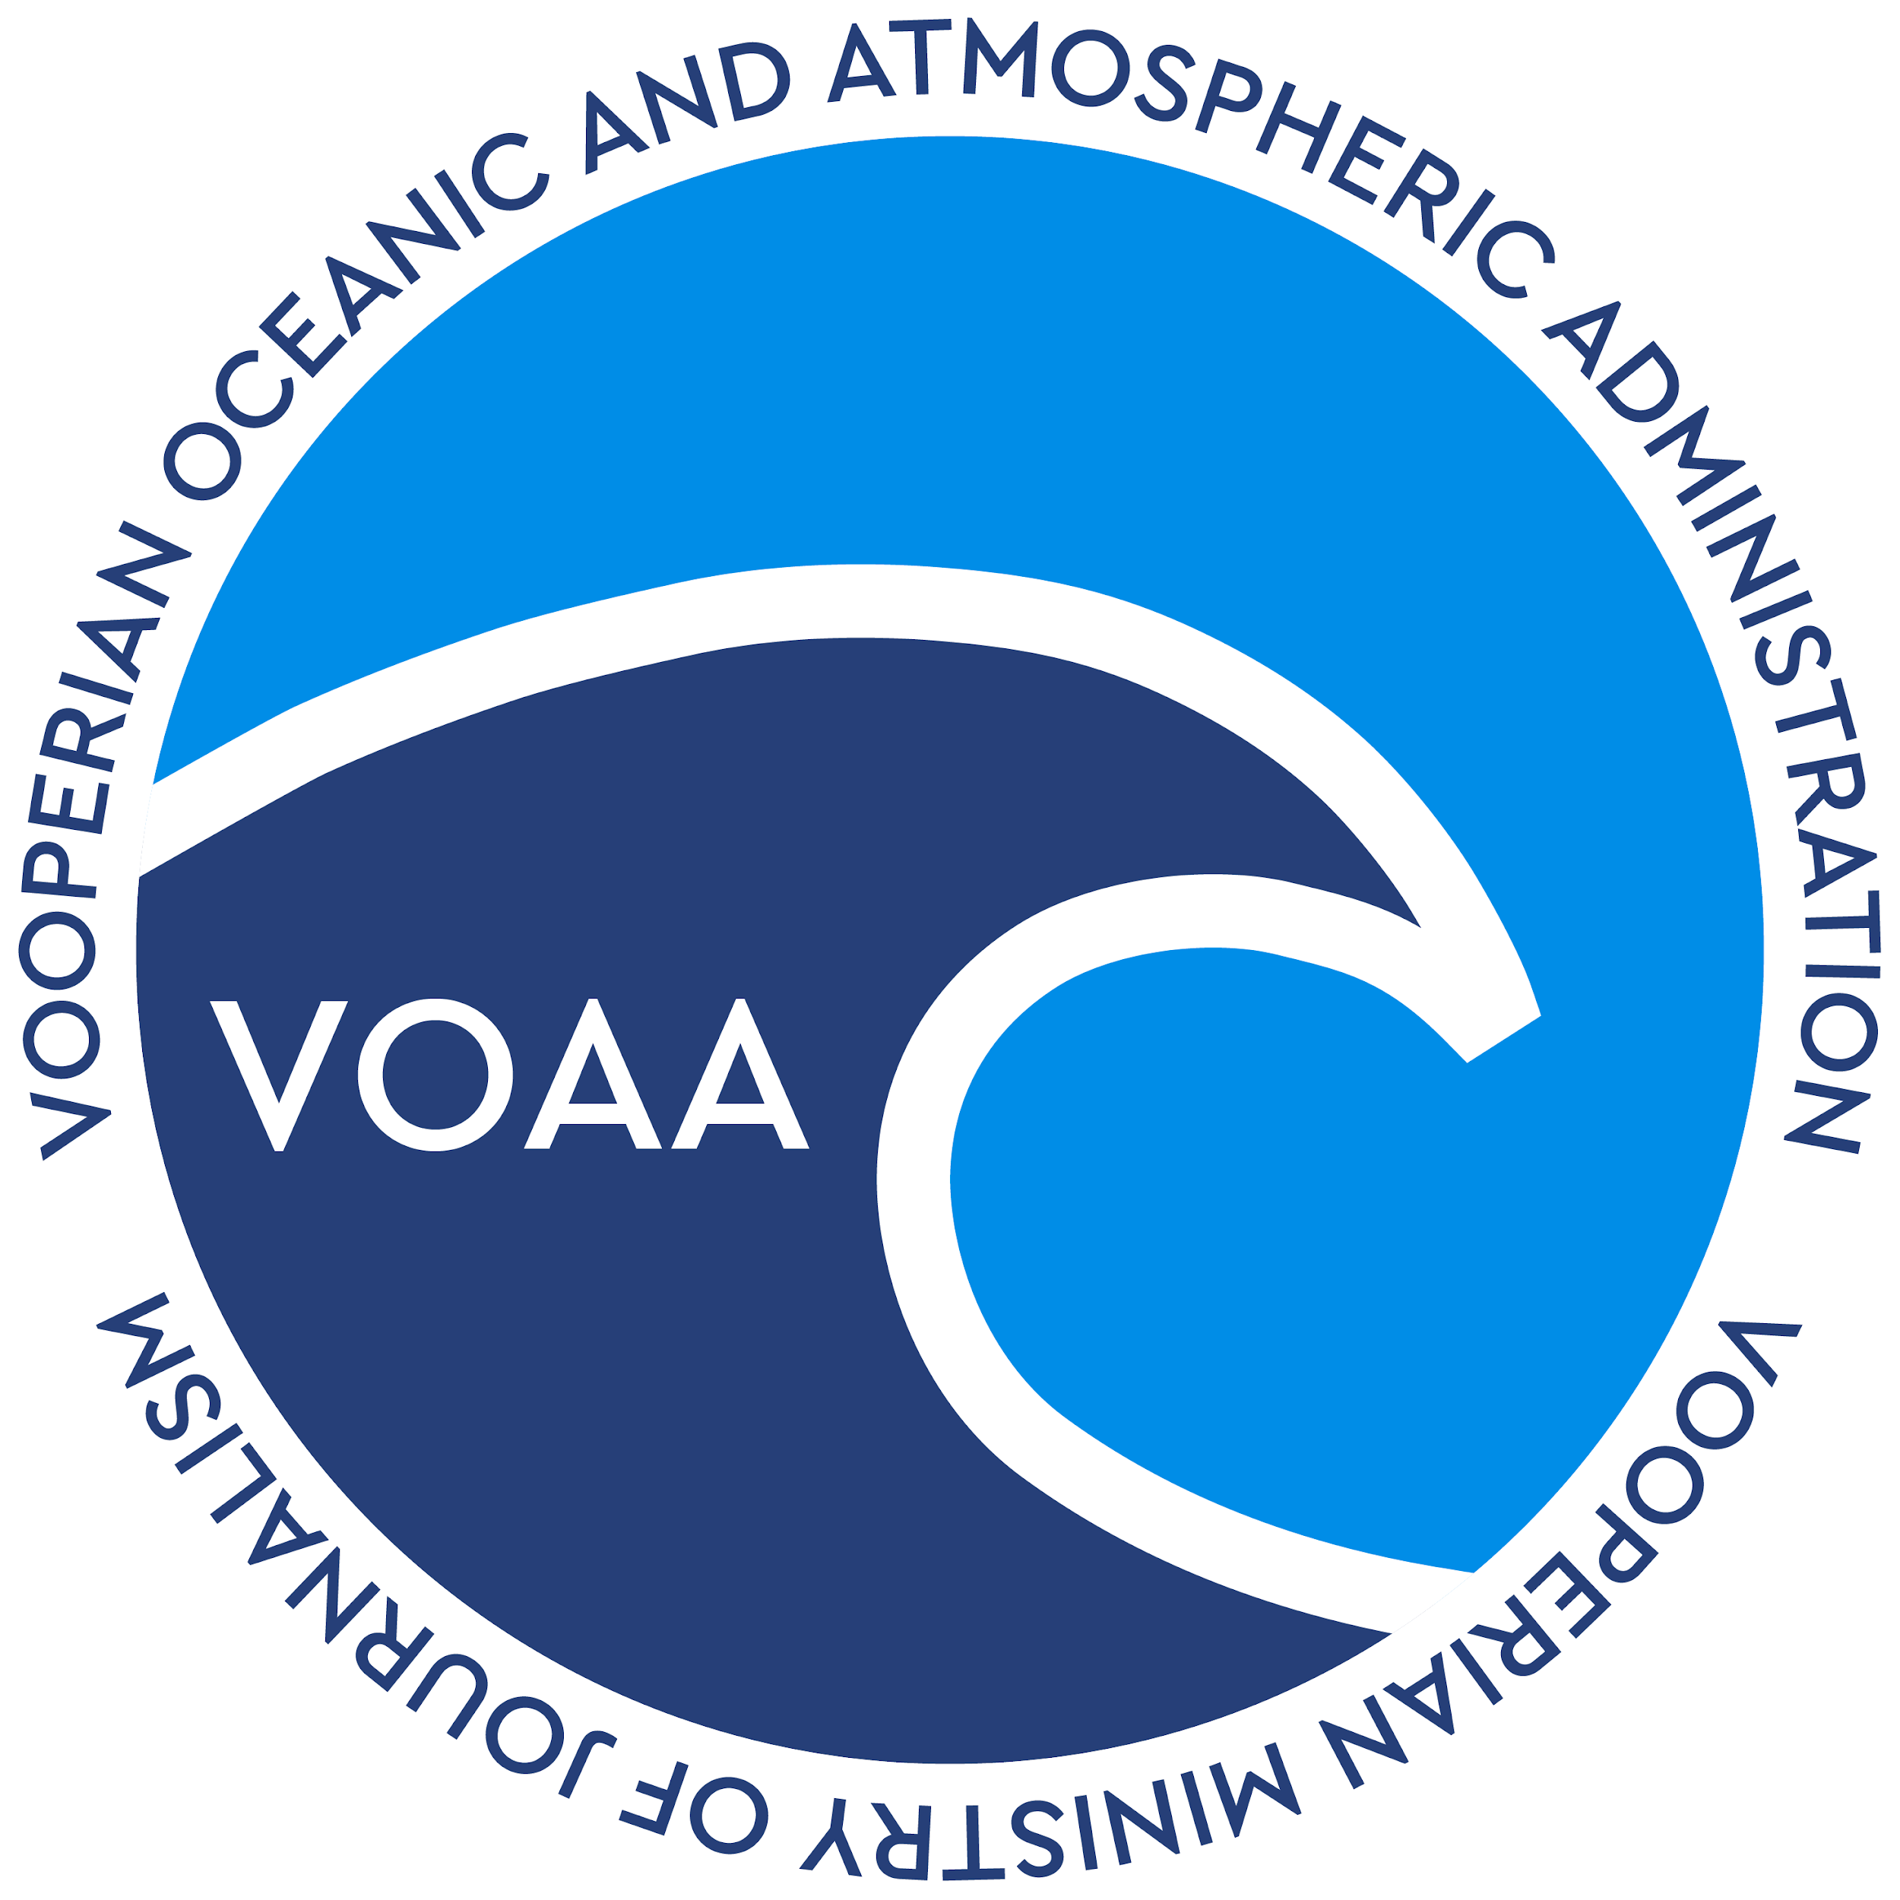

**END OF DOCUMENT**